Company/ Client: NCOC N. V. | Project: ESKENE WEST KARABATAN |  |  | Location: Sulphur Plant Tr.01
Tag No:  A1-550-VA-150 | Component examined | Material | SA516GR.70 | Work order: 27885933
Procedure No:  QP-11-UTT-Q01 REV 00 | Component examined | Día X Nominal Thickness | - | Probe Details
Manufacturing Code/Acceptance Standard: As per client specification | Component examined | Operating Temp | Ambient | Probe | OLYMPUS  D790  S/N: 1058416
Method: Contact | Reference Calibration Block Details | Block | Step wedge | Angle | 0º
Method: Contact | Reference Calibration Block Details | Range | (6.25 – 25) mm | Frequency | 5 MHz
Equipment: Olympus 38DLP S/N:171421601 | Reference Calibration Block Details | Accuracy | 0.3mm | size | 11 mm
Equipment: Olympus 38DLP S/N:171421601 | Reference Calibration Block Details | Temperature | Ambient | Crystal | Dual
Surface condition: Coated | Correction factors | N/A |  | Reference sensitivity | 2nd backwall reflection to 80% FSH
Couplant: Gel | Correction factors |  |  | Scan Sensitivity | Reference dB
Job Description:
- UT has been carried out on selected location and spot reading taken. More info in section Details and Results.
- Inspection done on Painted Surface.
- Inspection done on External surface of the vessel.

Legend:
FSH: Full Screen Height, N/A: Not Applicable

DETAILS AND RESULTS
Observed thickness during UT thickness measurements:

S/NO | Item description | DIA(Ø) | Nominal WT | East  (3 o’clock) | West | North | South | Top | Bottom | Centre
1 | Section 1 (Head) | - | 12.0 | 12.4 | 12.1 | - | - | 12.0 | 11.9 | 12.1
2 | Section 2 (Shell) | - | 25.0 | 26.9 | 27.0 | - | - | 26.8 | 26.9 | -
3 | Section 3 (Shell) | - | 14.0 | 16.3 | 15.4 | - | - | 15.7 | 16.4 | -
4 | Section 4 (Head) | - | 12.0 | 12.2 | 12.1 | - | - | 11.9 | 12.5 | 13.5
5 | Section 5 (Boot Shell) | - | 14.0 | 14.3 | 14.6 | 14.1 | 14.5 | - | - | -
6 | Section 6 (Boot Head) | - | 12.0 | 12.4 | 12.6 | 12.6 | 12.5 | 12.9 | - | -
7 | Nozzle N2 | 6” | 14.27 | 16.6 | 16.1 | 16.7 | 16.4 | - | - | -
8 | Nozzle N3 | 18” | 14.0 | 15.7 | 15.7 | 15.5 | 15.0 | - | - | -
9 | Nozzle N5 | 2” | 13.46 | 15.5 | 15.0 | 15.6 | 15.5 | - | - | -
10 | Nozzle N6 | 2” | 11.07 | 11.6 | 11.3 | 11.3 | 11.6 | - | - | -
11 | Nozzle N7 | 2” | 11.07 | 11.6 | 11.6 | 11.7 | 11.5 | - | - | -
12 | Manway M1 | 24” | 14.0 | 14.6 | 14.6 | 14.5 | 14.6 | - | - | -

A1-550-VA-150

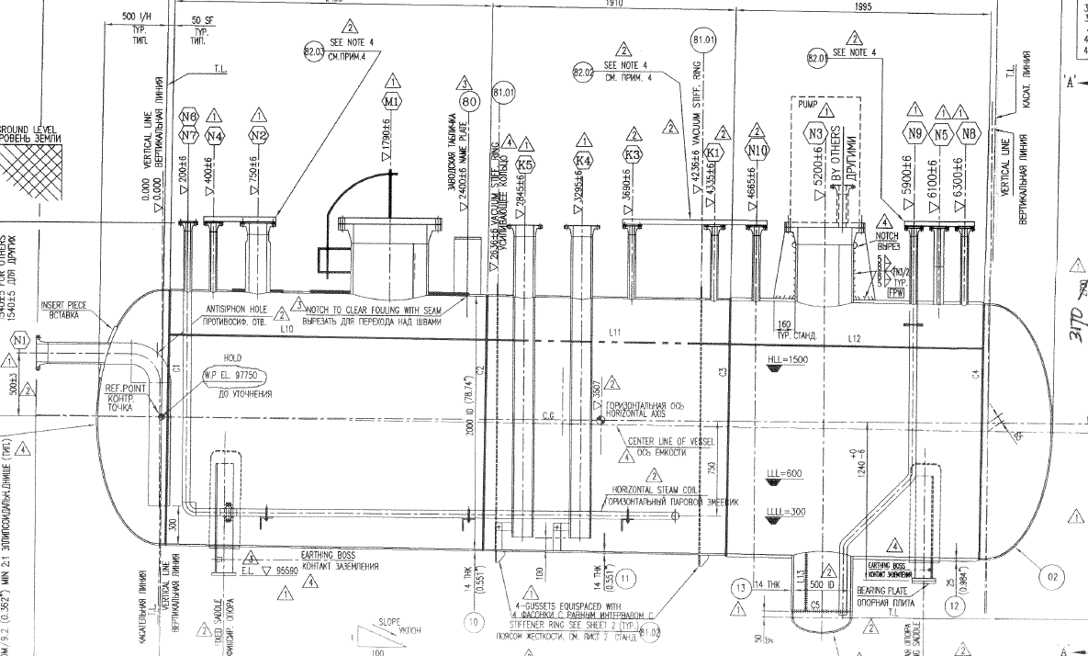

N6/ N7
Sec 1
Sec 6
Sec 5
Sec 4
Sec 3
Sec 2
N2
N5
N3
M1
Southside
NORTH

North
side

Note: All readings taken on the painted surface toward the North. All dimension mentioned in mm.

DETAILS AND RESULTS
A1-550-VA-150

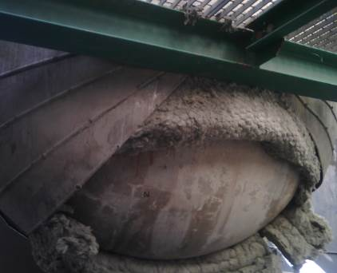
Section 1
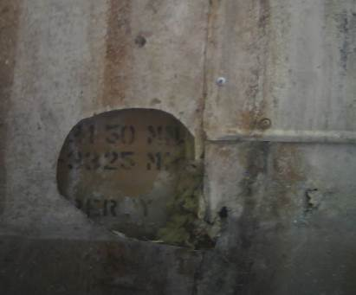
Section 2
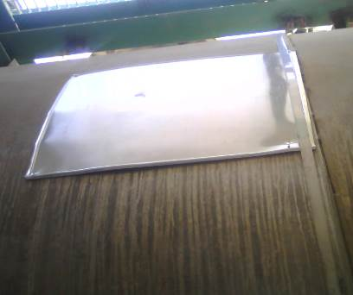
Section 3

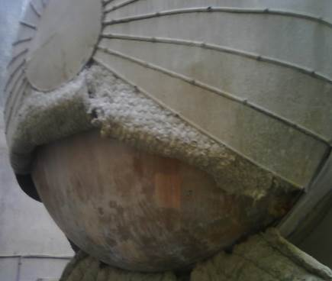
Section 4
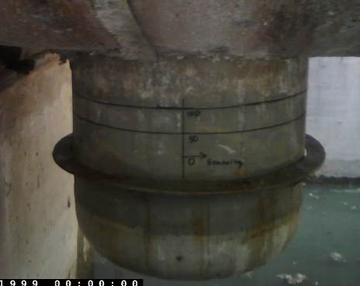
Section 5
Section 6
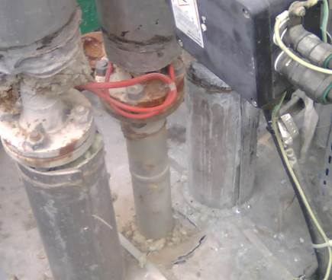
Nozzle N5
UTT Area

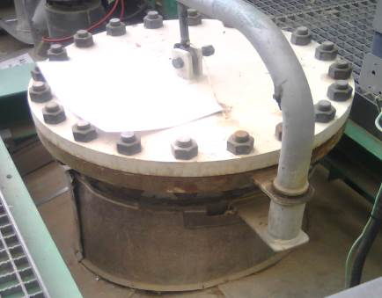
Nozzle M1
UTT Area
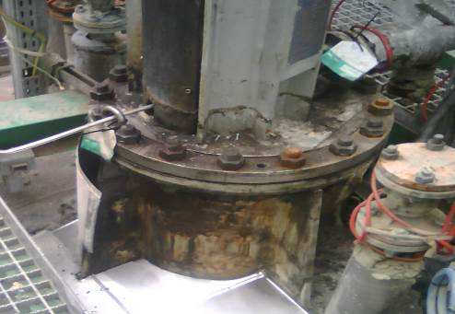
Nozzle N3
UTT Area
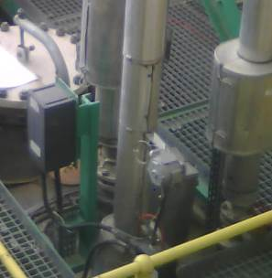
Nozzle N2
UTT Area

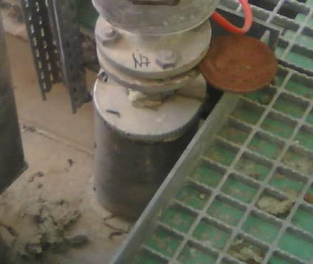
Nozzle N7
UTT Area
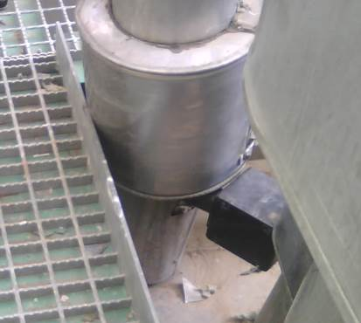
Nozzle N6
UTT Area

DETAILS AND RESULTS
Thickness observed on raster scanning:
A1-550-VA-150

S/NO | Item description | Nominal WT | Min | Max
1 | Boot head | 12.0 | 11.9 | 12.7
2 | Vessel head 1 | 12.0 | 12.8 | 13.7
3 | Vessel head 2 | 12.0 | 12.2 | 13.0

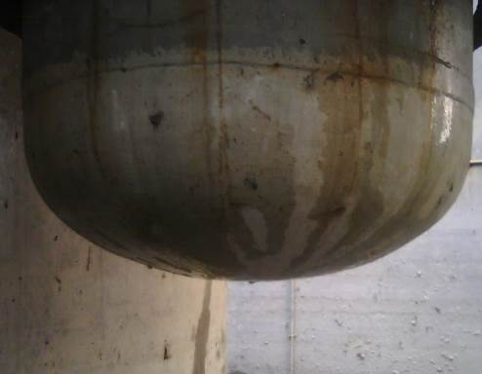
UT Scanning area
1
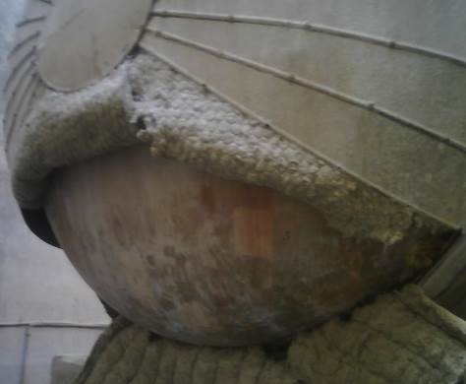
UT Scanning area
2
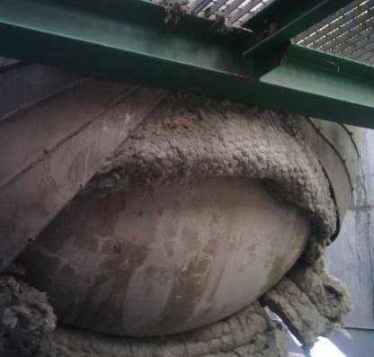
UT Scanning area
3

Note:
All readings taken on the painted surface.
Raster scanning has been performed on Boot and bottom section of Vessel head 1 & 2.

